Thirsk Community Primary School

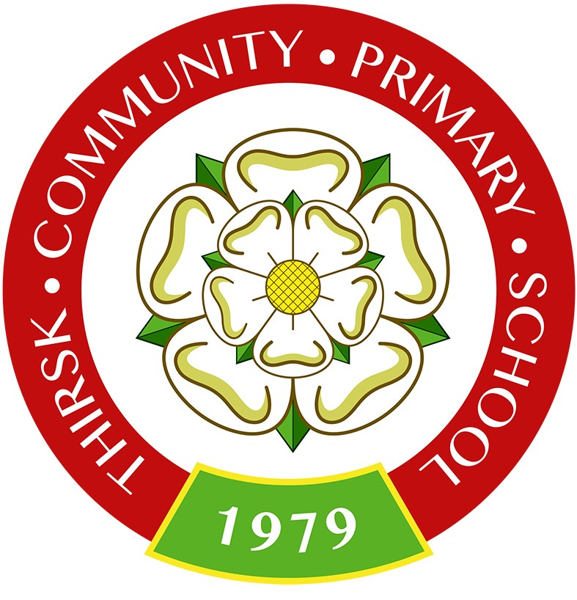

RSE & PSHE Policy

Date of creation: | June 2025
Date of consultation with parents | June 2025
Date of Policy Adoption Governing Body | July 2025
Date of Review: | July 2026

Relationships, Sex and Health Education (RSHE) is lifelong learning about physical, sexual, moral and emotional development. It is about the understanding of the importance of stable and loving relationships, respect, love and care, for family life. It involves acquiring information, developing skills and forming positive beliefs, values and attitudes.
Definition
RSHE supports children and young people’s personal development including their spiritual, moral, social and cultural development. Its aims are to help children and young people to deal with the real-life issues they face as they grow up and that they will encounter as adults. Their learning will support them both online and offline, to make informed choices about their safety, physical and mental health, enabling them to live positive and fulfilled lives.
Aims
The aims of our RSHE is to provide balanced and factual information about physical and emotional changes. Our PSHE Programme (Kapow) aims to prepare pupils, through an age and maturity appropriate curriculum, which will prepare them for an adult life, in which they can:
- Provide a framework in which sensitive discussions can take place for all children.
- Provide children with a framework to enable them to make healthy and positive choices in their relationships.
- Prepare children for puberty and give them an understanding of sexual development and the importance of health and hygiene
- Help children develop feelings of confidence, self-respect and empathy
- Teach children the correct vocabulary to describe themselves and their bodies
- Create a positive culture around issues of relationships and an understanding of safe relationships in different context e.g., peer and family.
- Provide children with the personal attributes of: kindness, consideration, respect, honesty and truthfulness, asking and giving consent and the concept of personal privacy.
- Preparing children for key transitions in their lives and providing strategies they can use to manage these situations e.g., the next stage of education and adulthood.
- Develop positive and inclusive attitudes to everyone, particularly to those with protected characteristics under the Equality Act 2010.
Statutory Requirements:
The law was changed with effect from September 2020 so that primary schools in England must teach relationships education and health education (The Children and Social Work Act 2017).
- The relationships education part of the new curriculum teaches what children need to learn to build positive and safe relationships with family and friends and online.
- The health education part of the new curriculum covers both physical health and mental wellbeing and teaches children how to make good decisions about their own health and wellbeing; how to recognise issues in themselves and in others; and how to seek support as early as possible when issues arise.

Sex education is not compulsory in primary schools, but:
- The new curriculum for relationships education and health education does include content on puberty.
- The national curriculum for science includes subject content in related areas, such as the main external body parts; the human body as it grows from birth to old age (including puberty); and reproduction in some plants and animals.

Following this change in the law, the Department for Education published Statutory Guidance for Relationships Education, Relationships and Sex Education (RSE) and Health Education (2019). This guidance requires primary schools in England to have a written relationships education policy to cover the following:
- How relationships education is delivered
- What sex education (if any) a school chooses to cover that goes beyond the national curriculum for science and relationships education.

There is no equivalent requirement for a health education policy but, in line with best practice, this RSHE policy also covers health education.
This RSHE policy also supports legal requirements relating to the following:
- The Equality Act 2010.
- The Education Act 1996.
- Statutory guidance, Keeping Children Safe in Education 2020.

The following policies are also relevant to this Relationships and Health Education policy:
- Anti-bullying
- Safe-guarding
- Spiritual, moral, social and cultural development
- Behaviour policy
- Science policy
- Child protection
Curriculum:
The school adopts the following approaches to organise the curriculum to ensure high quality delivery of RSHE:
- PSHE is taught through weekly or once every two week lessons:
  - for KS1 – lessons should be 40 - 45 minutes long;
  - for KS2 – lessons should be 50 - 60 minutes long.
- RSE is covered within the PSHE curriculum.
The lessons are taught by confident staff who are able to tackle sensitive topics within lessons.

Curriculum Content:
The school has chosen to use the Kapow Primary RSE scheme of work, which provides full curriculum coverage, including all the statutory content, for each year group.
The Kapow Primary scheme is a whole school approach that consists of three areas of learning in EYFS: Reception (to match the EYFS Personal, social and emotional development prime area) and five areas of learning across Key stages 1 and 2.

EYFS:
- Self-regulation
- Building relationships
- Managing self

Key stage 1 and 2:
- Families and relationships
- Health and wellbeing
- Safety and the changing body
- Citizenship
- Economic wellbeing

Teaching and learning

RSHE is delivered in line with the teaching and learning policy. However, as the subject deals with real-life experiences, it is important to establish a safe and positive learning environment using the following approaches:
- Establishing clear ground rules in consultation with children. Ground rules should include confidentiality, respect for others, privacy and boundaries.
- Using clear language to avoid misunderstandings.
- Avoiding prejudice and assumptions about children’s abilities, desires, background and experiences.
- Dealing sensitively with unexpected questions and comments.
- Assessing and building on existing knowledge and experiences.
- Ensuring that learning is engaging, using a range of activities, including structured discussion and problem-solving.
- Providing a range of opportunities to learn, practise and demonstrate knowledge, skills and attitudes.
- Allowing time for reflection.

Equality:
Under the Equality Act 2010, the school is under a legal duty to eliminate discrimination, advance equality of opportunity and foster good relationships between those with protected characteristics and those without. The protected characteristics are:
- Age.
- Marriage and Civil partnership.
- Disability.
- Race.
- Religion and belief.
- Sexual orientation.
- Sex.
- Pregnancy and maternity.
- Gender reassignment.

The RSHE programme will meet the needs of all children. Lessons will include content that will tackle discrimination and foster good relationships.
SEND:
Pupils with special educational needs will be given the opportunity to fully participate in RSE lessons, with adapted work provided where necessary.
Right to withdraw:
A parent or carer cannot legally withdraw their child from any aspect of the statutory relationships education or health education.
A parent or carer does have the right to withdraw their child from sex education unless what is being taught is part of the science national curriculum.
Following a consultation with the whole school community, the following content is deemed to be sex education:
- Year 6: Safety and the changing body, Lesson 5: Conception
- Year 6: Safety and the changing body, Lesson 6: Pregnancy and birth
If a parent or career wishes to withdraw their child from sex education, they should contact the headteacher.
Safeguarding:
RSHE includes sensitive topics. It is, therefore, possible that discussions will prompt safeguarding disclosures. Reference should be made to safeguarding policies and procedures to deal with these appropriately.
The subject leader/teacher should discuss with the designated safeguarding lead any potentially sensitive topics. Appropriate steps must be taken to provide additional support for children if required.
Staff should consider the timing of lessons to ensure that children have the opportunity to report any concerns they may have either that day or the following day.
Roles and Responsibility:
An effective programme of RSHE requires support from the whole school community and the following people have specific roles and responsibilities:
Governors
- The governing board will hold the head teacher to account for the implementation of this policy.
- The governing board will review and approve the content of this policy annually.

Headteacher:
The head teacher is responsible for ensuring that RSE is taught consistently across the school, and for managing requests to withdraw pupils from non-science components of RSE
- Overseeing the development and delivery of RSHE.
- Providing staff with the opportunity to contribute to the development of RSHE.
- Providing information to the trustees/governors.
- Providing training for the subject leader and staff, as required.
- Supporting the subject leader to liaise with parents and carers.
- Dealing with parents and carers who wish to withdraw a child from sex education.

Subject Leader:
The subject lead is responsible for:
- Leading the development and delivery of effective RSHE.
- Keeping up-to-date with the development of RSHE.
- Supporting colleagues as required.
- Monitoring and evaluating RSHE and providing necessary reports.
- Liaising with parents and carers.
- Keeping subject information up-to-date, including on the school website.

All Staff:
Staff are responsible for teaching RSE:
- To understand and implement the policy of RSHE.
- To teach RSHE in line with the agreed curriculum.
- To assess and monitor the progress of children.
- To respond to the needs of individual children.

