|  |  |
| --- | --- |
| **Thirsk Community Primary School**          **Thirsk Community Primary School Attendance and Punctuality Policy** | |
| **Date of creation :** | June 2024 |
| **Date of Policy Adoption Governing Body :** | **July 2024** |
| **Date for next Review:** | July 2025 |

**Contents**

1. School vision and the importance of school attendance
2. Working together to improve attendance
3. Roles and responsibilities
4. The law on school attendance and the right to a full-time education
5. Attendance legal intervention
6. Who to contact for support with attendance
7. Attendance Targets
8. Promoting and incentivising good attendance

This policy should be read alongside other school policies which support learning. This policy has been produced with regard to the DfE statutory guidance (applicable from 19.08.24) ‘Working Together to Improve School Attendance’.

1. **School vision on attendance and the importance of school attendance**

Our vision is to build strong relationships and work jointly with families, listening to and understanding barriers to attendance and working in partnership with families to remove them and develop and maintain a whole school culture that promotes the benefits of high attendance.

Improving attendance is everyone’s business. The barriers to accessing education are wide and complex, both within and beyond the school gates, and are often specific to individual pupils and families. Good attendance begins with school being somewhere pupils want to be and therefore the foundation of securing good attendance is that school is a calm, orderly, safe, and supportive environment where all pupils are keen and ready to learn.

Some pupils find it harder than others to attend school and therefore at all stages of improving attendance, schools and partners should work in partnership with pupils and parents collaboratively to remove any barriers to attendance by building strong and trusting relationships and working together to put the right support in place. Securing good attendance cannot therefore be seen in isolation, and effective practices for improvement will involve close interaction with schools’ efforts on curriculum, behaviour, bullying, special educational needs support, pastoral and mental health and wellbeing, and effective use of resources, including pupil premium. It cannot solely be the preserve of a single member of staff, or organisation, it must be a concerted effort across all teaching and non-teaching staff in school, the trust or governing body, the local authority, and other local partners.

1. **Working together to improve attendance**

Successfully treating the root causes of absence and removing barriers to attendance, at home, in school or more broadly requires schools and local partners to work collaboratively in partnership with, not against families. All partners should work together to:

**Expect**

Aspire to high standards of attendance from all pupils and parents and build a culture where all can, and want to, be in school and ready to learn by prioritising attendance improvement across the school.

**Monitor**

Rigorously use attendance data to identify patterns of poor attendance (at individual and cohort level) as soon as possible so all parties can work together to resolve them before they become entrenched.

**Listen and understand**

When a pattern is spotted, discuss with pupils and parents to listen to and understand barriers to attendance and agree how all partners can work together to resolve them.

**Facilitate support**

Remove barriers in school and help pupils and parents to access the support they need to overcome the barriers outside of school. This might include an early help or whole family plan where absence is a symptom of wider issues.

**Formalise support**

Where absence persists and voluntary support is not working or not being engaged with, partners should work together to explain the consequences clearly and ensure support is also in place to enable families to respond. Depending on the circumstances this may include formalising support through an attendance contract or education supervision order.

**Enforce**

Where all other avenues have been exhausted and support is not working or not being engaged with, enforce attendance through statutory intervention: a penalty notice in line with the National Framework or prosecution to protect the pupil’s right to an education.

1. **Roles and responsibilities**

**School and our day to day process for managing attendance**:

* **The school day begins at 8:40am and finishes at 3:15pm for Early Years and Key Stage 1 (Year 1 and Year 2) and 3:20 pm for Key Stage 2 (Year 3, 4, 5 and 6).**
* **Morning registration takes place between 8:40am and 8:50am**
* If a child arrives after 8:50am but before 9:10am when the register formally closes, they will receive an L code
* School asks Parents/Carers of late children to sign children into school on the electronic sign in, with a reason why they are late. Parents/Carers will need to bring their children to the school office as all other school doors/gates will be locked. Staff will record how many minutes late the pupil is and the reason they are late on Arbor. Parents/Carers who consistently bring their children to school late will be called in to a meeting with the Headteacher**.**
* If a child arrives after 9:10am and a suitable reason has been given, a U code - unauthorised absence - will be used
* If a child arrives after 9:10am and the reason for absence has not yet been established, an N code will be used until school can establish the reason for the child’s absence. Once the reason for the absence has been ascertained, the correct absence code should be entered but no more than 5 school days after the session
* If a child arrives after 9:10am but before the end of the session a U code – unauthorised - will be used
* When no reason for absence is established or the school is not satisfied that the reason given is one that would be recorded using one of the codes statistically classified as authorised, then an O code will be used
* **Afternoon registration takes place from 12:55pm until 1:05pm**
* If a child arrives after 1:05pm but before 1:25pm when the register formally closes, they will receive an L code. The same process and codes for the morning session will apply to the afternoon session.
* Notifications by Parents/Carers of pupil absences are recorded on Arbor to track attendance.
* Our Admin team are responsible for first day calling and recording information received if parents have not contacted the school
* If no contact and/or explanation for absence form Parents/Carers has been received on the second day, the School Attendance Champion will begin the process to establish contact
* School will ask the Police to make a Welfare Call or make a referral to Social Care if Parents/Carers continually fail to answer phone calls or give reasons for absence for children with poor attendance
* Staff use Arbor to record attendance and the school uses the Department for Education absence and attendance codes as outlined in *Working together to improve school attendance*
* Pupils may be marked as unable to attend due to exceptional circumstances e.g. serious disruption to travel caused by the weather or an emergency school closure.
* The Headteacher or appropriate senior leader has responsibility for considering all leave of absence for exceptional circumstances including holidays, and will only authorise such requests in exceptional circumstances as stated in *Working together to improve school attendance*
* Poor attendance is monitored and if necessary, Parents/Carers will be asked to an informal meeting with the School Attendance Champion to address the problems
* Pupils who go below 93% attendance will be contacted by the School Attendance Champion notifying them of this and asking to work together to improve the attendance
* Persistent Absence - With effect from 1st September 2015, a pupil will be deemed to be a ‘persistent absentee’ where their attendance falls below 90%. Missing this amount of school has a significant, detrimental impact on a child’s learning. Parents/Carers will be asked to attend a meeting with the Headteacher/School Attendance Champion to identify how we can work together to improve their child’s attendance
* The Headteacher/School Attendance Champion will liaise with the Early Help Service if a Family Outreach Worker is involved with the family.
* Promotion of regular school attendance will take place on a daily basis
* Parents/Carers will be asked to provide medical evidence for children with poor attendance due to illness.
* Regular analysis of attendance and absence data will take place to identify pupils or cohorts that require support with their attendance and put effective strategies in place. Please see the chart below on effective school attendance improvement and management.

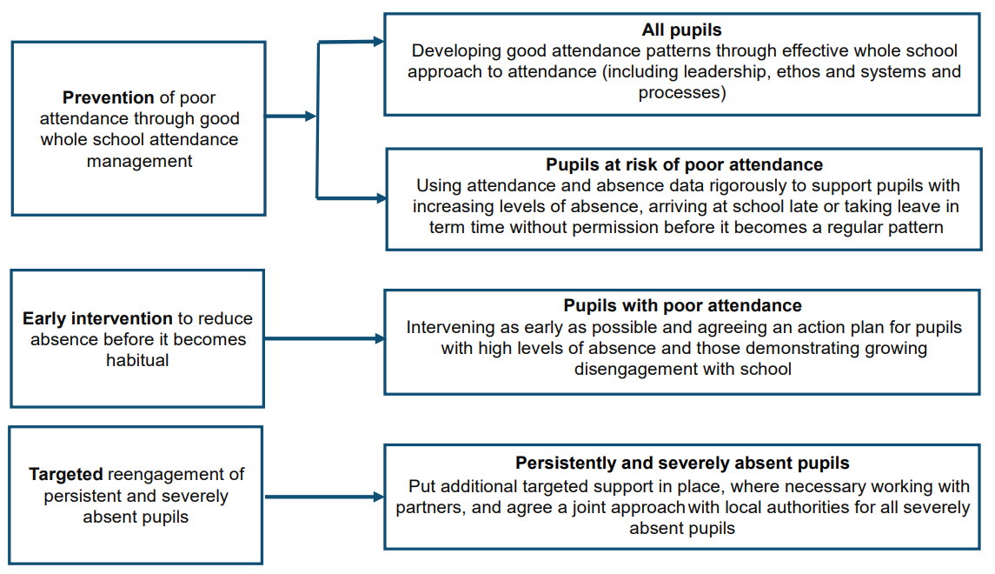

**Pupils:**

* All pupils should be aware of the importance of regular school attendance. If a pupil is having difficulties which might be preventing them from attending school regularly, they should speak to their class teacher, Headteacher or the School Attendance Champion
* Pupils are expected to attend school regularly and to be on time for registration and ready to learn.

**Parents and Carers:**

* If a pupil is prevented from attending school because of sickness (both physical or mental health related) it is the responsibility of the parent to contact the school on the first day of their child’s absence. An I code will be given in this instance. If contact is not made with the school, an unauthorised mark - Code N - will be given until sufficient written or verbal confirmation of the absence is received.
* Pupils arriving late should be brought to the school office. Parents/Carers will then sign the late register on the electronic sign in, giving reasons for lateness. These records are monitored weekly and Parents/Carers of pupils who are regularly late are invited to school to discuss support measures with the School Attendance Champion.
* Wherever possible, Parents/Carers should avoid making medical/dental appointments for their children during school hours. The school will request that proof of appointments be shown to the staff in the School Office. If proof is not provided, a U code - unauthorised absence - will be used
* If a Parent/Carer wishes to request a leave of absence they should complete a Leave of Absence During Term Time Request Form and return it to the school office. This form can be obtained from the school office. This form must be fully completed and clear.
* Parents/Carers do not have the right to take children out of school for a holiday during term time. A Parent/Carer wishing to apply for a leave of absence for exceptional circumstances will need to apply using the Leave of Absence During Term Time Request Form. This form is available from the office. Requests should be applied for 6 school weeks before the absence is required. Parents/Carers will receive a written response within a few days.
* It is an expectation that Parents/Carers will work with school and/or other local partners to resolve attendance issues
* As absence is so often a symptom of wider issues a family is facing, schools, trusts and local authorities should always work together with other local partners to understand the barriers to attendance and provide support. Where that is not successful, or is not engaged with, the law protects pupils’ right to an education and provides a range of legal interventions to formalise attendance improvement efforts, and where all other avenues have been exhausted, enforce it through prosecuting parents. Attendance legal intervention can only be used for pupils of compulsory school age and decisions should be made on an individual case by case basis

# The law on school attendance and the right to full-time education

Under the 1996 Education Act, Parents and Carers are responsible for ensuring their children attend school regularly and punctually. Failure to do so could result in legal intervention taking place

The law entitles every child of compulsory school age to an efficient, full-time education suitable to their age, aptitude, and any special educational need they may have. It is the legal responsibility of every parent to make sure their child receives that education either by attendance at a school or by education otherwise than at a school.

Where Parents/Carers decide to have their child registered at school, they have an additional legal duty to ensure their child attends that school regularly. This means their child must attend every day that the school is open, except in a small number of allowable circumstances such as being too ill to attend or being given permission for an absence in advance from the school.

This is essential for pupils to get the most out of their school experience, including their attainment, wellbeing, and wider life chances. The pupils with the highest attainment at the end of key stage 2 have higher rates of attendance over the key stage compared to those with the lowest attainment. At key stage 2, pupils not meeting the expected standard in reading, writing and maths had an overall absence rate of 4.7%, compared to 3.5% among those meeting the expected standard. Moreover, the overall absence rate of pupils not meeting the expected standard was higher than among those meeting the higher standard (4.7% compared to 2.7%).

For the most vulnerable pupils, regular attendance is also an important protective factor and the best opportunity for needs to be identified and support provided. Research has shown associations between regular absence from school and a number of extrafamilial harms, including crime (the proportion of children that had been cautioned or sentenced for any offence that had ever been persistently absent was 81% and for serious violence offence was 85%)

The school admission register, sometimes known as the ‘the school roll’, must be kept in accordance with the School Attendance (Pupil Registration) (England) Regulations 2024. Regulation 8 sets out the contents of the admission register

All schools can grant a leave of absence when a pupil needs to be absent from school with permission. All schools are expected to restrict leaves of absence to the specific circumstances set out in regulation 11 of the School Attendance (Pupil Registration) (England) Regulations 2024 and schools maintained by a local authority and special schools not maintained by a local authority must do so.

1. **Attendance legal intervention**

Schools, trusts and local authorities are expected to work together and make use of the full range of legal interventions rather than relying solely on penalty notices or prosecution. It is for individual schools and local authorities to decide whether to use them in an individual case after considering the individual circumstances of a family. These are: Attendance contracts, Education supervision orders, Attendance prosecution, Parenting orders and Penalty notices. The chart below outlines providing support first before attendance legal intervention looks:

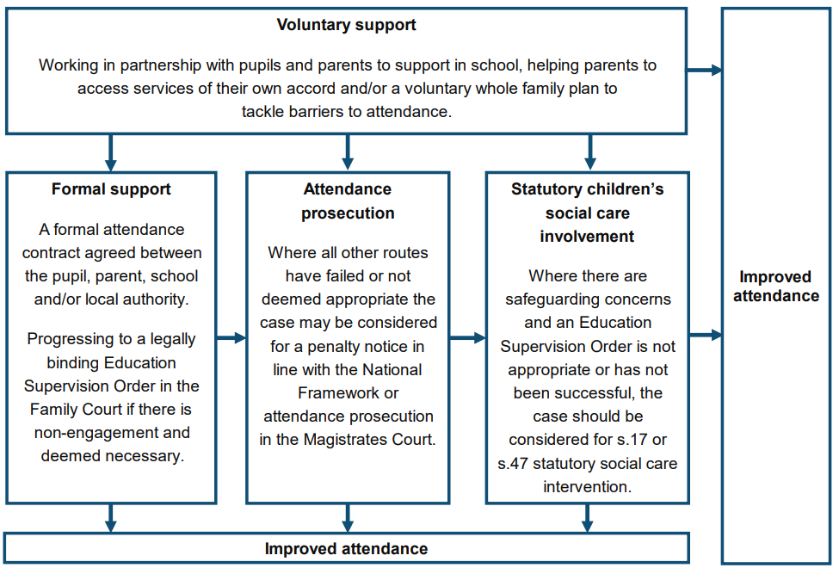

Where they are used, it should be clear that it is the most appropriate intervention to change parental behaviour and in making the decision to use an intervention, headteachers and local authority officers should have regard to their safeguarding duties as set out in the statutory guidance on Keeping Children Safe in Education.

Schools and local authorities should decide which Parent(s)/Carer(s) to involve in attendance legal intervention, but this should usually be the parent or parents who have allowed the absence.

Where a family chooses to take a holiday during term time which is not authorised, the absence will be coded as unauthorised - G code - and legal intervention may take place where 5 or more days of unauthorised absence are recorded.

If leave of absence is taken without the request having been agreed, the absence will be recorded as unauthorised with the appropriate code. This may result in legal intervention taking place.

Legal intervention may take place where there have been at least 10 sessions of unauthorised absence during the previous 10 school weeks. This includes unauthorised late arrivals, coded U, which count as unauthorised absence for the whole session.

In compliance with the Education Act 436A (Chapter 2 Part 6) the school will, after making appropriate checks, report all Children Missing from Education to the Local Authority, Education Welfare Service, who has a duty to investigate the whereabouts of such children and negotiate their prompt return to suitable education.

For further guidance please refer to:

NYC: - [School Attendance | CYPSinfo (northyorks.gov.uk)](https://cyps.northyorks.gov.uk/school-attendance)

Working together to improve school attendance: applies from 19th August 2024 - <https://www.gov.uk/government/publications/working-together-to-improve-school-attendance>

1. **Who to contact for support with attendance**

If you have concerns about your child’s attendance, the first person to speak to would be the class teacher of the child. They can be contacted via the school office. If this contact has not led to improved attendance, then Parents/Carers may be signposted to contact our School Attendance Champion – Ms. Kennedy – to further continue the supportive process.

The school telephone number is 01845 524349. The school admin email is [admin@thirsk-pri.n-yorks.sch.uk](mailto:admin@thirsk-pri.n-yorks.sch.uk)

1. **Attendance targets**

Each school has an annual attendance target set by Senior Leadership and Governors. It is expected that the whole school community will work together to achieve this target which, for Thirsk Community Primary School, is 96%

Attainment is strongly linked to attendance, and research has shown that if pupils are to achieve their full potential, they must attend school regularly.

1. **Promoting and incentivising good attendance**

The school recognises that sometimes medical appointments during school time are unavoidable. Absences due to medical appointments where proof has been shared with the school office will not be counted when acknowledging good attendance.

Pupils in each class will work together to achieve the best collective attendance each week. 100% attendance equals 20 minutes reward time and 96% - 99.9% equals 15 minutes reward time. Each class can set their own award to aim for each half term/term.

Certificates are given out at the end of each half term:

* Pupils who have achieved 100% attendance gold
* Pupils who have achieved 98% - 99.9% attendance silver
* Pupils who have achieved 96% - 98.9% attendance
* A positive message is sent out to Parents/Carers when a child’s attendance rises from below 93% to above 93%

Two pupils from each class who have an attendance mark of 96% or above for the half term will be randomly selected to receive a small prize.

**Appendix A**

**Thirsk Community Primary School Cause for Concern Overview Relating to Attendance**

The highest standards of attendance and punctuality are encouraged for all pupils at all times. School will endeavor to work with all Parents/Carers to assist them in carrying out their duties as required by the DfE. Where a child’s attendance causes concern, the following parameters and actions will be considered by the Headteacher/School Attendance Champion. Each case will be considered individually based on circumstances.

|  |  |
| --- | --- |
| **Cause for concern** | **Action(s) to be considered** |
| 95% attendance or below at any point within an academic year | • Attendance will be monitored by the School and attendance history considered.  • Contact with Parents/Carers if necessary. **PREVENTION** |
| 93% attendance or below at any point within an academic year | • Contact Parents/Carers asking them to work with the School Attendance Champion to improve attendance. **EARLY INTERVENTION** |
| 90% attendance or below at any point within an academic year | • Targeted support will be put in place with the School Attendance Champions and where necessary, other partners in the local authority. **TARGETED** |
| Repeated incidences of illness-related absence | • Contact made with Parents/Carers by the School Attendance Champion and strategies established to improve attendance  • Referral to school nurse.  • Request that Parents/Carers provide proof of doctor’s involvement (appointment card with child’s name on / letter / copy of prescription etc).  • Work for the pupil might be sent home to be completed. |
| Repeated arrival at school after 8:50am | • Contact made with Parents/Carers by the School Attendance Champion and strategies established to improve attendance |
| Repeated arrival at school after 9.10am | • Contact made with Parents/Carers by the School Attendance Champion and strategies established to improve attendance |
| Persistent and severe absence | Where absence escalates and pupils miss 10% or more of school (equivalent to 1 day or more a fortnight across a full school year), schools and local authorities are expected to work together to put additional targeted support in place to remove any barriers to attendance and reengage these pupils. In doing so, schools should sensitively consider some of the reasons for absence and understand the importance of school as a place of safety and support for children who might be facing difficulties, rather than reaching immediately for punitive approaches.  If no improvement is seen, legal intervention will take place. |